Aero t : Descriptive Statistics & Probability

# About AeroFit

About Aero t

Aero t is a leading brand in the eld of tness equipment. Aero t provides a product range including machines such as treadmills, exercise bikes, gym equipment, and tness accessories to cater to the needs of all categories of people.

Problem Statement :

The market research team at AeroFit wants to identify the characteristics of the target audience for each type of treadmill o ered by the company, to provide a better recommendation of the treadmills to the new customers. The team decides to investigate whether there are di erences across the product with respect to customer characteristics.

Goal

Perform descriptive analytics to create a customer pro le for each AeroFit treadmill product by developing appropriate tables and charts.

# Importing the required libraries for the analysis

*# Importing all the necessary libraries needed for computing, visualizing, model building.*

**import**

numpy

**as**

np

**import**

pandas

**as**

pd

**import**

matplotlib.pyplot

**as**

plt

**import**

seaborn

**as**

sns

In [1]:

Importing the Dataset

**!**

gdown

15

lzphg3S4M5URVxqgtP_VST7Y0y-rMGW

Downloading...

From: https://drive.google.com/uc?id=15lzphg3S4M5URVxqgtP_VST7Y0y-rMGW

To: /content/aerofit_treadmill.csv

100

% 7.28k/7.28k [00:00<00:00, 18.4MB/s

]

In [3]:

# Basic Analysis : Getting to know the dataset

df

**=**

pd

**.**

read_csv

(

'aerofit_treadmill.csv'

)

print

(

f

"The dataset is of the shape

{

df

**.**

shape

}

."

)

df

The dataset is of the shape (180, 9).

P

rodu

c

t

A

ge

G

ender

E

du

ca

tion

Ma

rit

a

l

S

t

a

tus

U

s

a

ge

F

itness

I

n

c

ome

M

iles

0

KP

281

18

Ma

le

14

S

ingle

3

4

29562

112

In [5]:

Out[5]:

|  |  |  |  |  |  |  |  |  |  |
| --- | --- | --- | --- | --- | --- | --- | --- | --- | --- |
| 1 | KP281 | 19 | Male | 15 | Single | 2 | 3 | 31836 | 75 |
| 2 | KP281 | 19 | Female | 14 | Partnered | 4 | 3 | 30699 | 66 |
| 3 | KP281 | 19 | Male | 12 | Single | 3 | 3 | 32973 | 85 |
| 4 | KP281 | 20 | Male | 13 | Partnered | 4 | 2 | 35247 | 47 |
| ... | ... | ... | ... | ... | ... | ... | ... | ... | ... |
| 175 | KP781 | 40 | Male | 21 | Single | 6 | 5 | 83416 | 200 |
| 176 | KP781 | 42 | Male | 18 | Single | 5 | 4 | 89641 | 200 |
| 177 | KP781 | 45 | Male | 16 | Single | 5 | 5 | 90886 | 160 |
| 178 | KP781 | 47 | Male | 18 | Partnered | 4 | 5 | 104581 | 120 |
| 179 | KP781 | 48 | Male | 18 | Partnered | 4 | 5 | 95508 | 180 |

180 rows × 9 columns

df

**.**

info

()

In [6]:

<

class 'pandas.core.frame.DataFrame'

>

RangeIndex: 180 entries, 0 to 179

Data columns (total 9 columns):

# Column Non-Null Count Dtype

---

------ -------------- -----

0

Product 180 non-null object

1

Age 180 non-null int64

2

Gender 180 non-null object

3

Education 180 non-null int64

4

MaritalStatus 180 non-null object

5

Usage 180 non-null int64

6

Fitness 180 non-null int64

7

Income 180 non-null int64

8

Miles 180 non-null int64

dtypes: int64(6), object(3)

memory usage: 12.8+ KB

*Here we can con rm that the dataset consist of no null values since all the columns have 180 non-null values.*

*Also, the 'Product' is going to be our target/dependent variable for the analysis.*

*# To check presence of any duplicate records.*

np

**.**

any

(

df

**.**

duplicated

())

In [7]:

Out[7]: False

*# Checking the amount of null values in all the columns.*

df

**.**

isnull

()

**.**

sum

()

In [8]:

Product 0

Age 0

Gender 0

Education 0

MaritalStatus 0

Usage 0

Fitness 0

Income 0

Miles 0

dtype: int64

Out[8]:

*The dataset thus consists of no null values.*

*# Filtering the numerical columns*

num_cols

**=**

df

**.**

select_dtypes

(

np

**.**

number

)

**.**

columns

num_cols

In [9]:

Out[9]: Index(['Age', 'Education', 'Usage', 'Fitness', 'Income', 'Miles'], dtype='object')

*# Finding number of unique values from the numerical columns*

**for**

col

**in**

num_cols

:

print

(

f

"Number of unique values in

{

col

}

=

{

df

[

col

]

**.**

nunique

()

}

\n

"

)

Number of unique values in Age = 32

Number of unique values in Education = 8

Number of unique values in Usage = 6

Number of unique values in Fitness = 5

Number of unique values in Income = 62

Number of unique values in Miles = 37

In [10]:

*# Changing the data types of few columns to category which will save us some memory and reduce the execution time*

(

cat_cols

**:=**

df

**.**

columns

[

**~**

df

**.**

columns

**.**

isin

(

num_cols

)])

df

[

cat_cols

]

**=**

df

[

cat_cols

]

**.**

astype

(

'category'

)

df

**.**

info

()

<

class 'pandas.core.frame.DataFrame'

>

RangeIndex: 180 entries, 0 to 179

Data columns (total 9 columns):

# Column Non-Null Count Dtype

------ -------------- -----

---

Product 180 non-null category

0

1

Age 180 non-null int64

2

Gender 180 non-null category

3

Education 180 non-null int64

4

MaritalStatus 180 non-null category

5

Usage 180 non-null int64

6

Fitness 180 non-null int64

7

Income 180 non-null int64

8

Miles 180 non-null int64

dtypes: category(3), int64(6)

memory usage: 9.5 KB

In [11]:

We can see that Product, Gender and MaritalStatus columns in the following info has been changed into category type.

*# Get unique values and value counts of non-numerical columns*

**for**

col

**in**

cat_cols

:

print

(

f

"Unique values of

{

col

}

:-

{

df

[

col

]

**.**

unique

()

}

\n\n

Value_counts of

{

col

}

:-

\n

{

df

[

col

]

**.**

value_counts

()

}

\n

"

,

end

**=**

'-------------------------------------------------------------------------------

\n

'

)

Unique values of Product:- ['KP281', 'KP481', 'KP781']

Categories (3, object): ['KP281', 'KP481', 'KP781']

Value_counts of Product:-

Product

KP281 80

KP481 60

KP781 40

Name: count, dtype: int64

-------------------------------------------------------------------------------

Unique values of Gender:- ['Male', 'Female']

Categories (2, object): ['Female', 'Male']

Value_counts of Gender:-

Gender

Male 104

Female 76

Name: count, dtype: int64

-------------------------------------------------------------------------------

Unique values of MaritalStatus:- ['Single', 'Partnered']

Categories (2, object): ['Partnered', 'Single']

Value_counts of MaritalStatus:-

MaritalStatus

Partnered 107

Single 73

Name: count, dtype: int64

-------------------------------------------------------------------------------

In [12]:

pd

**.**

set_option

(

'display.float_format'

,

**lambda**

x

:

'

%.2f

'

**%**

x

)

(

df_numerical_description

**:=**

df

**.**

describe

())

A

ge

E

du

ca

tion

U

s

a

ge

F

itness

I

n

c

ome

M

iles

c

ount

180

.

00

180

.

00

180

.

00

180

.

00

180

.

00

180

.

00

In [13]:

Out[13]:

|  |  |  |  |  |  |  |
| --- | --- | --- | --- | --- | --- | --- |
| mean | 28.79 | 15.57 | 3.46 | 3.31 | 53719.58 | 103.19 |
| std | 6.94 | 1.62 | 1.08 | 0.96 | 16506.68 | 51.86 |
| min | 18.00 | 12.00 | 2.00 | 1.00 | 29562.00 | 21.00 |
| 25% | 24.00 | 14.00 | 3.00 | 3.00 | 44058.75 | 66.00 |
| 50% | 26.00 | 16.00 | 3.00 | 3.00 | 50596.50 | 94.00 |
| 75% | 33.00 | 16.00 | 4.00 | 4.00 | 58668.00 | 114.75 |
| max | 50.00 | 21.00 | 7.00 | 5.00 | 104581.00 | 360.00 |

# Outlier Detection and Processing

*# Substracting mean from median to find the outliers.*

*# Greater the number deviates from 0, the more outliers present in the columns,*

*# which we can easily verify using the boxplot*

df_numerical_description

**.**

loc

[

'50%'

]

**-**

df_numerical_description

**.**

loc

[

'mean'

]

In [15]:

Age -2.79

Education 0.43

Usage -0.46

Fitness -0.31

Income -3123.08

Miles -9.19

dtype: float64

Out[15]:

We can see that the 'Income' and the 'Miles' columns have high mean-median deviation, thereby we can say that they have higher number of outliers.

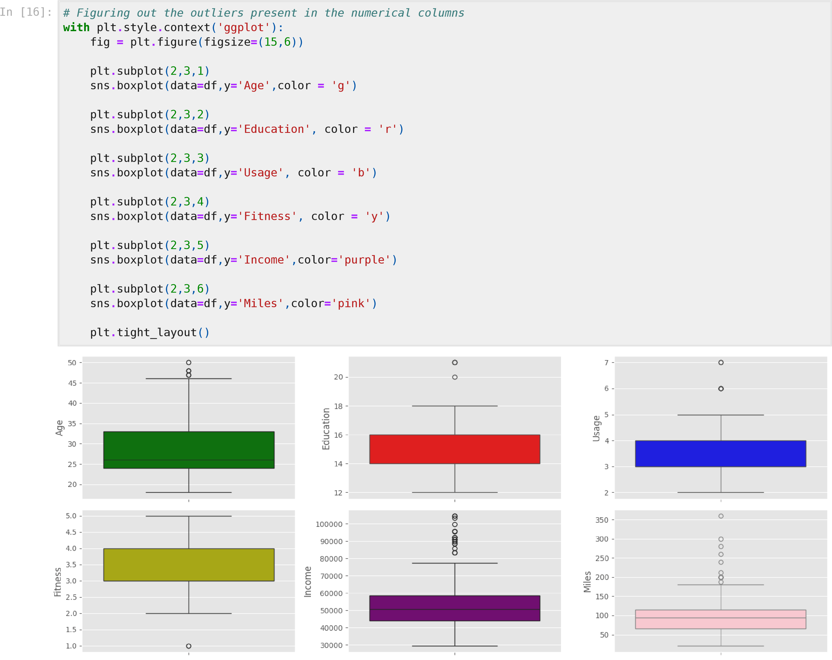

Observing the plot further cements our prior nding about the number of outliers in the 'Income' and the 'Miles' columns.

*Let us create a dataframe comprising of all the relevant statistical metrics for each column.*

**def**

find_outliers

(

df

):

q1

**=**

df

**.**

quantile

(

0.25

)

q3

**=**

df

**.**

quantile

(

0.75

)

iqr

**=**

q3

**-**

q1

median

**=**

df

**.**

median

()

lower_fence

**=**

round

(

q1

**-**

1.5

**\***

iqr

,

2

)

upper_fence

**=**

round

(

q1

**+**

1.5

**\***

iqr

,

2

)

min_

**=**

df

**.**

min

()

max_

**=**

df

**.**

max

()

outliers

**=**

df

[((

df

**<**

(

q1

**-**

1.5

**\***

iqr

))

**|**

(

df

**>**

(

q3

**+**

1.5

**\***

iqr

)))]

**.**

to_list

()

**return**

q1

,

q3

,

iqr

,

median

,

lower_fence

,

upper_fence

,

min_

,

max_

,

len

(

outliers

)

,

outliers

In [17]:

*# Create a new dataframe for our stats data of columns.*

stats_df

**=**

pd

**.**

DataFrame

(

data

**=**

**None**

,

columns

**=**

num_cols

)

*# Creating a new column for index. Will later set it as the index column.*

stats_df

[

'stats_index'

]

**=**

[

'q1'

,

'q3'

,

'iqr'

,

'median'

,

'lower_fence'

,

'upper_fence'

,

'min_'

,

'max_'

,

'outlier_count'

]

stats_df

**.**

set_index

(

'stats_index'

,

inplace

**=**

**True**

)

*# Capturing the outliers of all the columns in a dictionary.*

outliers_dict

**=**

dict

()

**for**

col

**in**

stats_df

**.**

columns

:

col_result

**=**

find_outliers

(

df

[

col

])

stats_df

[

col

]

**=**

col_result

[:

9

]

outliers_dict

[

col

]

**=**

col_result

[

**-**

1

]

stats_df

A

ge

E

du

ca

tion

U

s

a

ge

F

itness

I

n

c

ome

M

iles

In [18]:

Out[18]:

stats_index

q1 24.00 14.00 3.00 3.00 44058.75 66.00

|  |  |  |  |  |  |  |
| --- | --- | --- | --- | --- | --- | --- |
| q3 | 33.00 | 16.00 | 4.00 | 4.00 | 58668.00 | 114.75 |
| iqr | 9.00 | 2.00 | 1.00 | 1.00 | 14609.25 | 48.75 |
| median | 26.00 | 16.00 | 3.00 | 3.00 | 50596.50 | 94.00 |
| lower_fence | 10.50 | 11.00 | 1.50 | 1.50 | 22144.88 | -7.12 |
| upper_fence | 37.50 | 17.00 | 4.50 | 4.50 | 65972.62 | 139.12 |
| min_ | 18.00 | 12.00 | 2.00 | 1.00 | 29562.00 | 21.00 |
| max_ | 50.00 | 21.00 | 7.00 | 5.00 | 104581.00 | 360.00 |
| outlier_count | 5.00 | 4.00 | 9.00 | 2.00 | 19.00 | 13.00 |

In [19]: *# Printing the Outlier details.*

**for** col **in** outliers_dict: print(f'The {len(outliers_dict[col])} outliers in the \'{col}\' column are : {outliers_dict[col]}')

The 5 outliers in the 'Age' column are : [47, 50, 48, 47, 48]

The 4 outliers in the 'Education' column are : [20, 21, 21, 21]

The 9 outliers in the 'Usage' column are : [6, 6, 6, 7, 6, 7, 6, 6, 6]

The 2 outliers in the 'Fitness' column are : [1, 1]

The 19 outliers in the 'Income' column are : [83416, 88396, 90886, 92131, 88396, 85906, 90886, 103336, 99601, 89641, 95866, 92131, 92131, 104581, 83416, 89641, 90886, 104581, 95508] The 13 outliers in the 'Miles' column are : [188, 212, 200, 200, 200, 240, 300, 280, 260, 200, 360, 200, 200] We now have a dataframe that consists of all the essential parameters of each numerical column.

*However, if we look carefully at the 'lower_fence' of the 'Miles' column, we see that it is negative. But a person cannot plan to walk negative miles. So clearly that needs to be handled.*

*We'll replace it with the minimum value of the miles column.*

*# Replacing the lower_fence for the 'Miles' column with the minimum value in the column.*

stats_df

**.**

loc

[

'lower_fence'

,

'Miles'

]

**=**

df

[

'Miles'

]

**.**

min

()

stats_df

In [20]:

In [21]:

Out[21]: Age Education Usage Fitness Income Miles

stats_index

q1 24.00 14.00 3.00 3.00 44058.75 66.00

|  |  |  |  |  |  |  |
| --- | --- | --- | --- | --- | --- | --- |
| q3 | 33.00 | 16.00 | 4.00 | 4.00 | 58668.00 | 114.75 |
| iqr | 9.00 | 2.00 | 1.00 | 1.00 | 14609.25 | 48.75 |
| median | 26.00 | 16.00 | 3.00 | 3.00 | 50596.50 | 94.00 |
| lower_fence | 10.50 | 11.00 | 1.50 | 1.50 | 22144.88 | 21.00 |
| upper_fence | 37.50 | 17.00 | 4.50 | 4.50 | 65972.62 | 139.12 |
| min_ | 18.00 | 12.00 | 2.00 | 1.00 | 29562.00 | 21.00 |
| max_ | 50.00 | 21.00 | 7.00 | 5.00 | 104581.00 | 360.00 |
| outlier_count | 5.00 | 4.00 | 9.00 | 2.00 | 19.00 | 13.00 |

In order to reduce the outliers impact on the rest of the data, let us clip the data between the 5th percentile and the 95th percentile.

## Dataset clipping

clipped_df

**=**

df

In [22]:

Out[23]: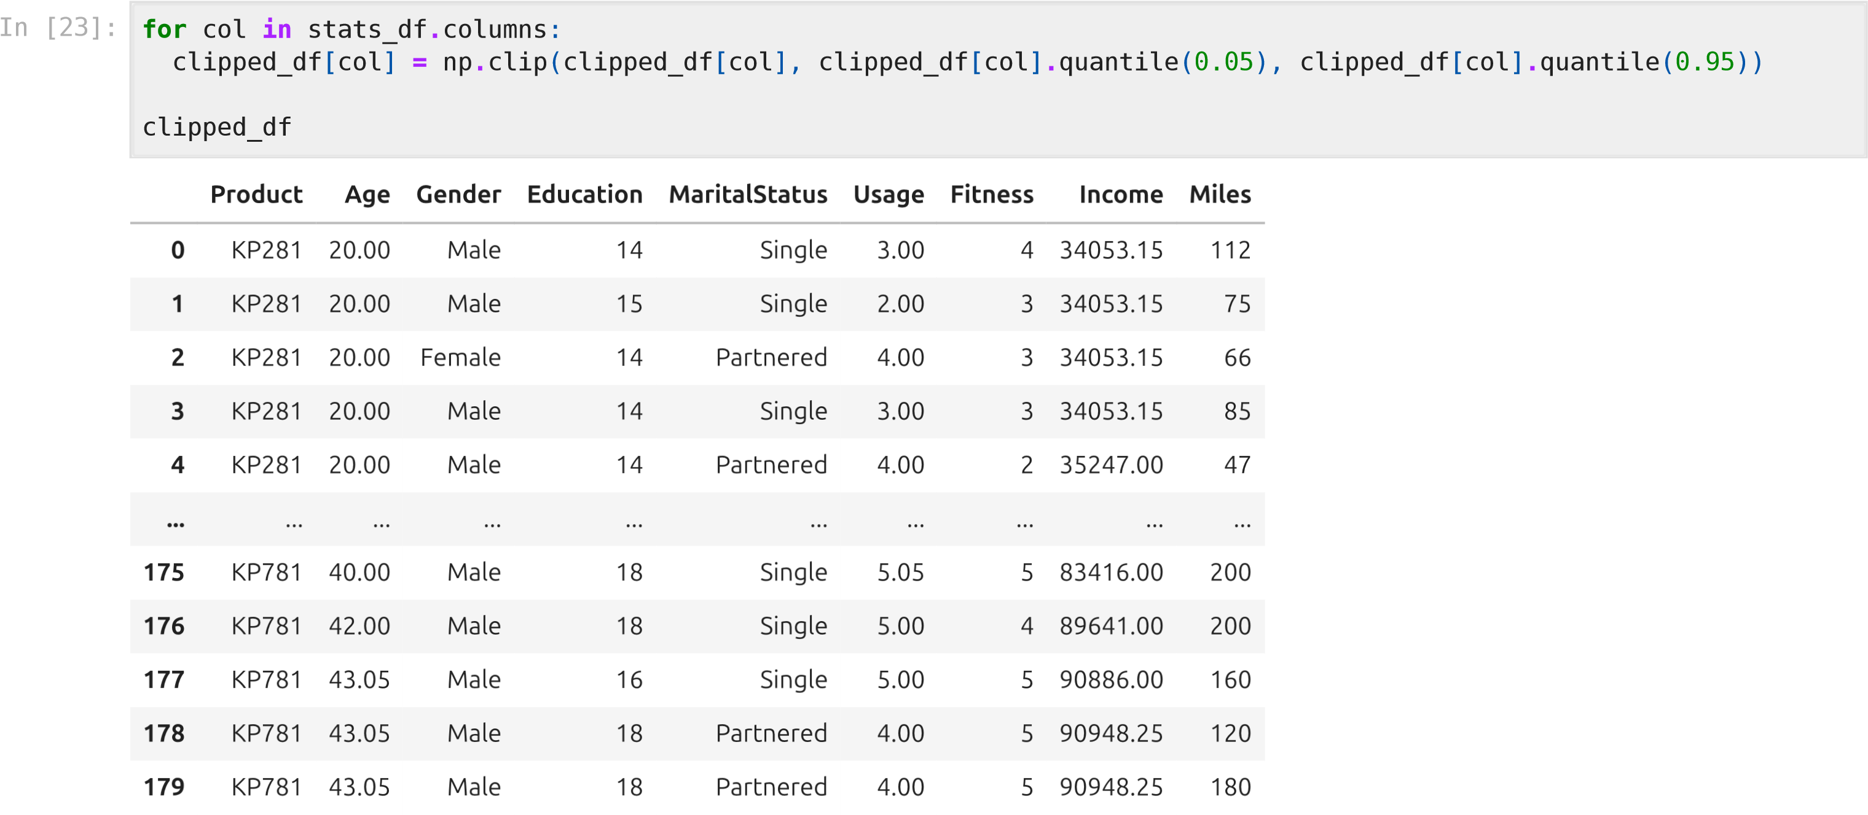

180 rows × 9 columns

In the resulting clipped_df, we can observe that post the calculations, the columns 'Age' and 'Usage' have oating point values which do not make sense for the type of data that they represent.

We will have to rectify that data to only contain int values for these columns.

*# Converting the 'Age' & 'Usage' to 'int'*

clipped_df

[[

'Age'

,

'Usage'

]]

**=**

clipped_df

[[

'Age'

,

'Usage'

]]

**.**

astype

(

int

)

clipped_df

P

rodu

c

t

A

ge

G

ender

E

du

ca

tion

Ma

rit

a

l

S

t

a

tus

U

s

a

ge

F

itness

I

n

c

ome

M

iles

0

KP

281

20

Ma

le

14

S

ingle

3

4

34053

.

15

112

In [24]:

Out[24]:

|  |  |  |  |  |  |  |  |  |  |  |  |  |  |  |
| --- | --- | --- | --- | --- | --- | --- | --- | --- | --- | --- | --- | --- | --- | --- |
| 1 | KP281 | 20 | Male |  |  | 15 |  | Single |  | 2 |  | 3 | 34053.15 | 75 |
| 2 | KP281 | 20 | Female |  |  | 14 |  | Partnered |  | 4 |  | 3 | 34053.15 | 66 |
| 3 | KP281 | 20 | Male |  |  | 14 |  | Single |  | 3 |  | 3 | 34053.15 | 85 |
| 4 | KP281 | 20 | Male |  |  | 14 |  | Partnered |  | 4 |  | 2 | 35247.00 | 47 |
| ... | ... | ... | ... |  |  | ... |  | ... |  | ... |  | ... | ... | ... |
| 175 | KP781 | 40 | Male |  |  | 18 |  | Single |  | 5 |  | 5 | 83416.00 | 200 |
| 176 | KP781 | 42 | Male |  |  | 18 |  | Single |  | 5 |  | 4 | 89641.00 | 200 |
| 177 | KP781 | 43 | Male |  |  | 16 |  | Single |  | 5 |  | 5 | 90886.00 | 160 |
| 178 | KP781 | 43 | Male |  |  | 18 |  | Partnered |  | 4 |  | 5 | 90948.25 | 120 |
| 179 | KP781 | 43 | Male |  |  | 18 |  | Partnered |  | 4 |  | 5 | 90948.25 | 180 |

180 rows × 9 columns

We will now be using the clipped_df as our nal dataset for our analysis.

# Basic visualizations : Relationships between variables

*Relationships between Categorical variables and the output variable* *Age vs the Product Purchases*

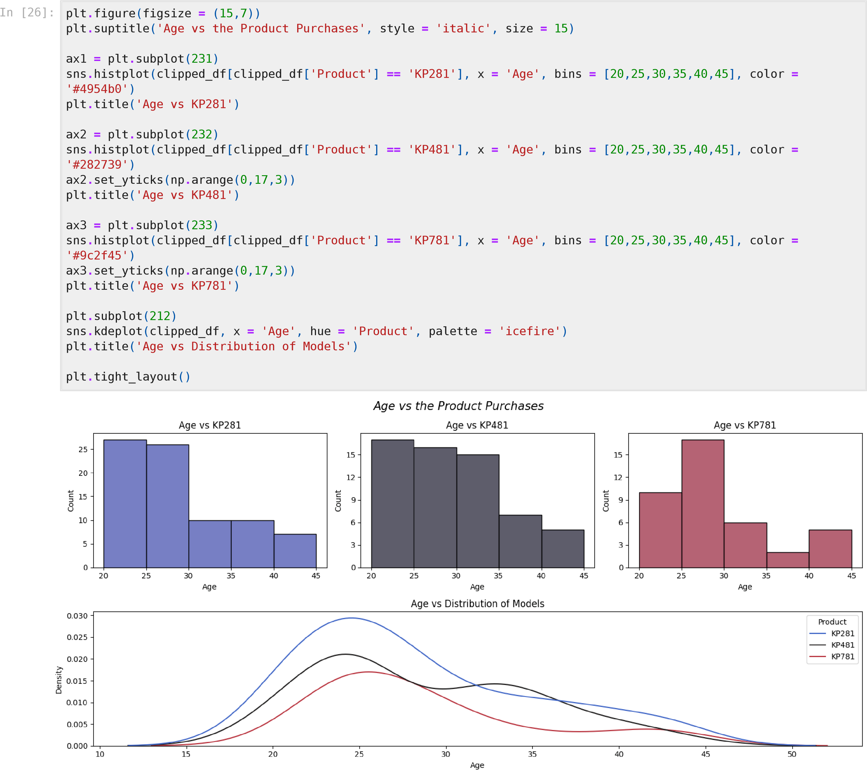

*Observations :*

People aged around 20 to 30 years have the most number of purchases.

The general trend of the customer's ages are that they're peaked between 20 to 30 and then slowly declining, indicating lesser customers of old age.

*Interesting insight here is that there's a sudden rise in the number of customers in their early 30's when it comes to the KP481 model, i.e. it is the go to model for the people in their early 30's.*

## Gender vs the Product purchase

plt

**.**

figure

(

figsize

**=**

(

15

,

7

))

sns

**.**

countplot

(

clipped_df

,

x

**=**

'Gender'

,

hue

**=**

'Product'

,

palette

**=**

'viridis'

)

plt

**.**

ylabel

(

'Number of Purchases'

)

plt

**.**

xlabel

(

'Gender of the Customer'

)

plt

**.**

title

(

'Relationship between the Gender of the customers and their Product choices'

)

plt

**.**

show

()

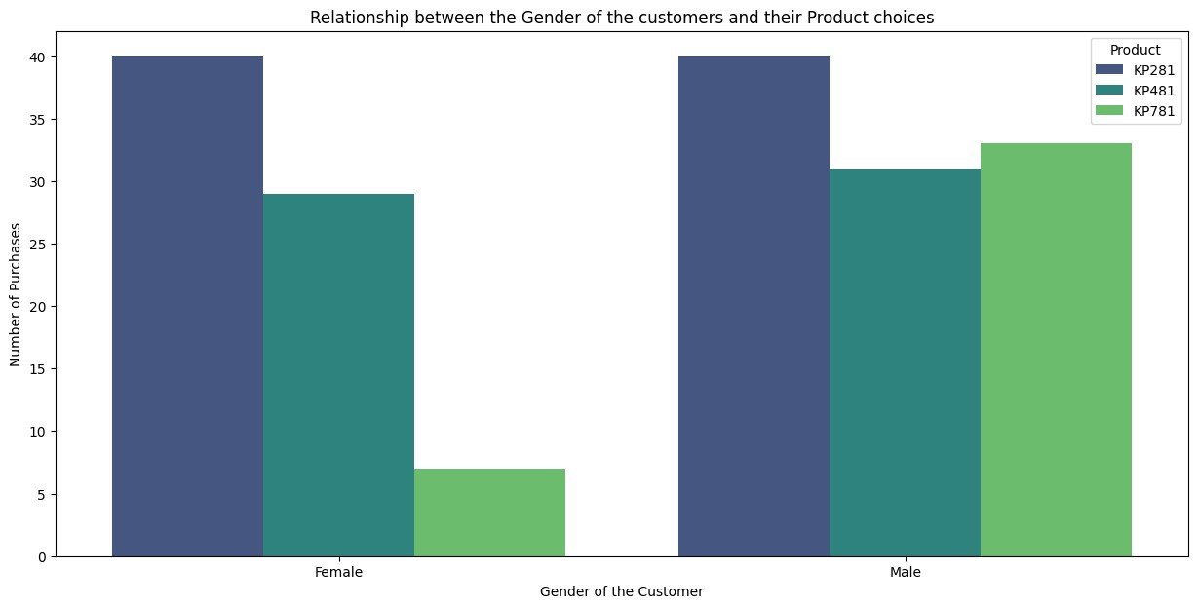

*Observations :*

From the above plot, it is clear that the KP281 and the KP481 models are more or less equally preferred by customers of both the Genders.

*Although when it comes to the KP781 model, it is seen that despite being the expensive one of the two, the model is preferred over the KP481 by customers of the 'Male' Gender, which can also be interpreted as the Males also tend to prefer more advanced features in their treadmills.*

## Marital status vs the Product purchase

sns

**.**

set_style

(

'darkgrid'

)

plt

**.**

figure

(

figsize

**=**

(

15

,

7

))

sns

**.**

countplot

(

clipped_df

,

x

**=**

'MaritalStatus'

,

hue

**=**

'Product'

,

palette

**=**

'rocket_r'

)

plt

**.**

ylabel

(

'Number of Purchases'

)

plt

**.**

xlabel

(

'Marital Status'

)

plt

**.**

title

(

'Relationship between the Marital status of customers and their Product choices'

)

plt

**.**

show

()

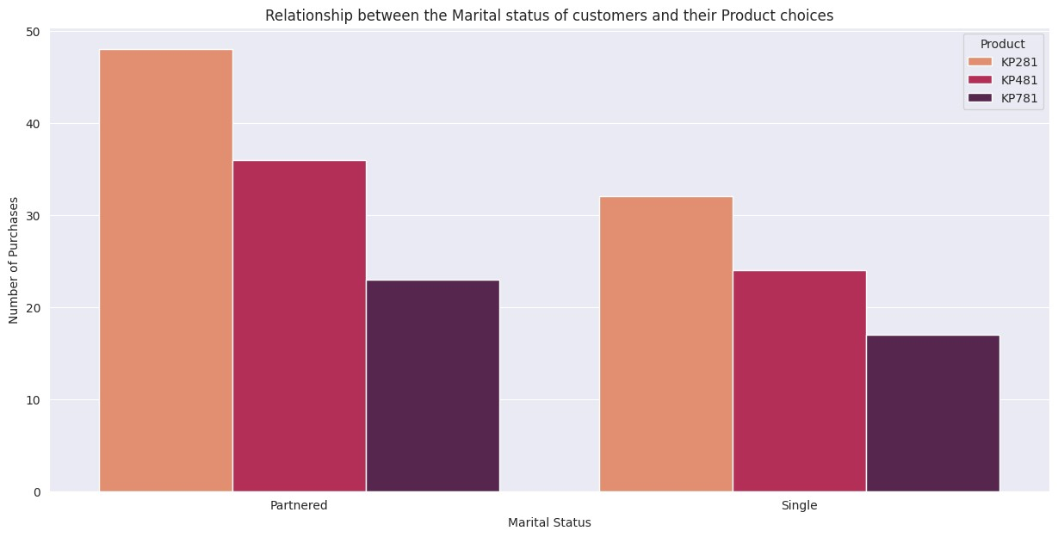

*Observations :*

From the above plot, we can infer that there is no speci c relationship between the marital status of the customer and the choice of product.

We can see that the KP281, being the aordable model, is the User's choice of trademill followed by the KP481 and the KP781 respectively, all of this, regardless of the Marital status of the customers.

*However, the interesting thing here is that the people who have Partners or Spouses with them, tend to purchase the products more than the single people.*

## Customer's Income vs the Product Purchase

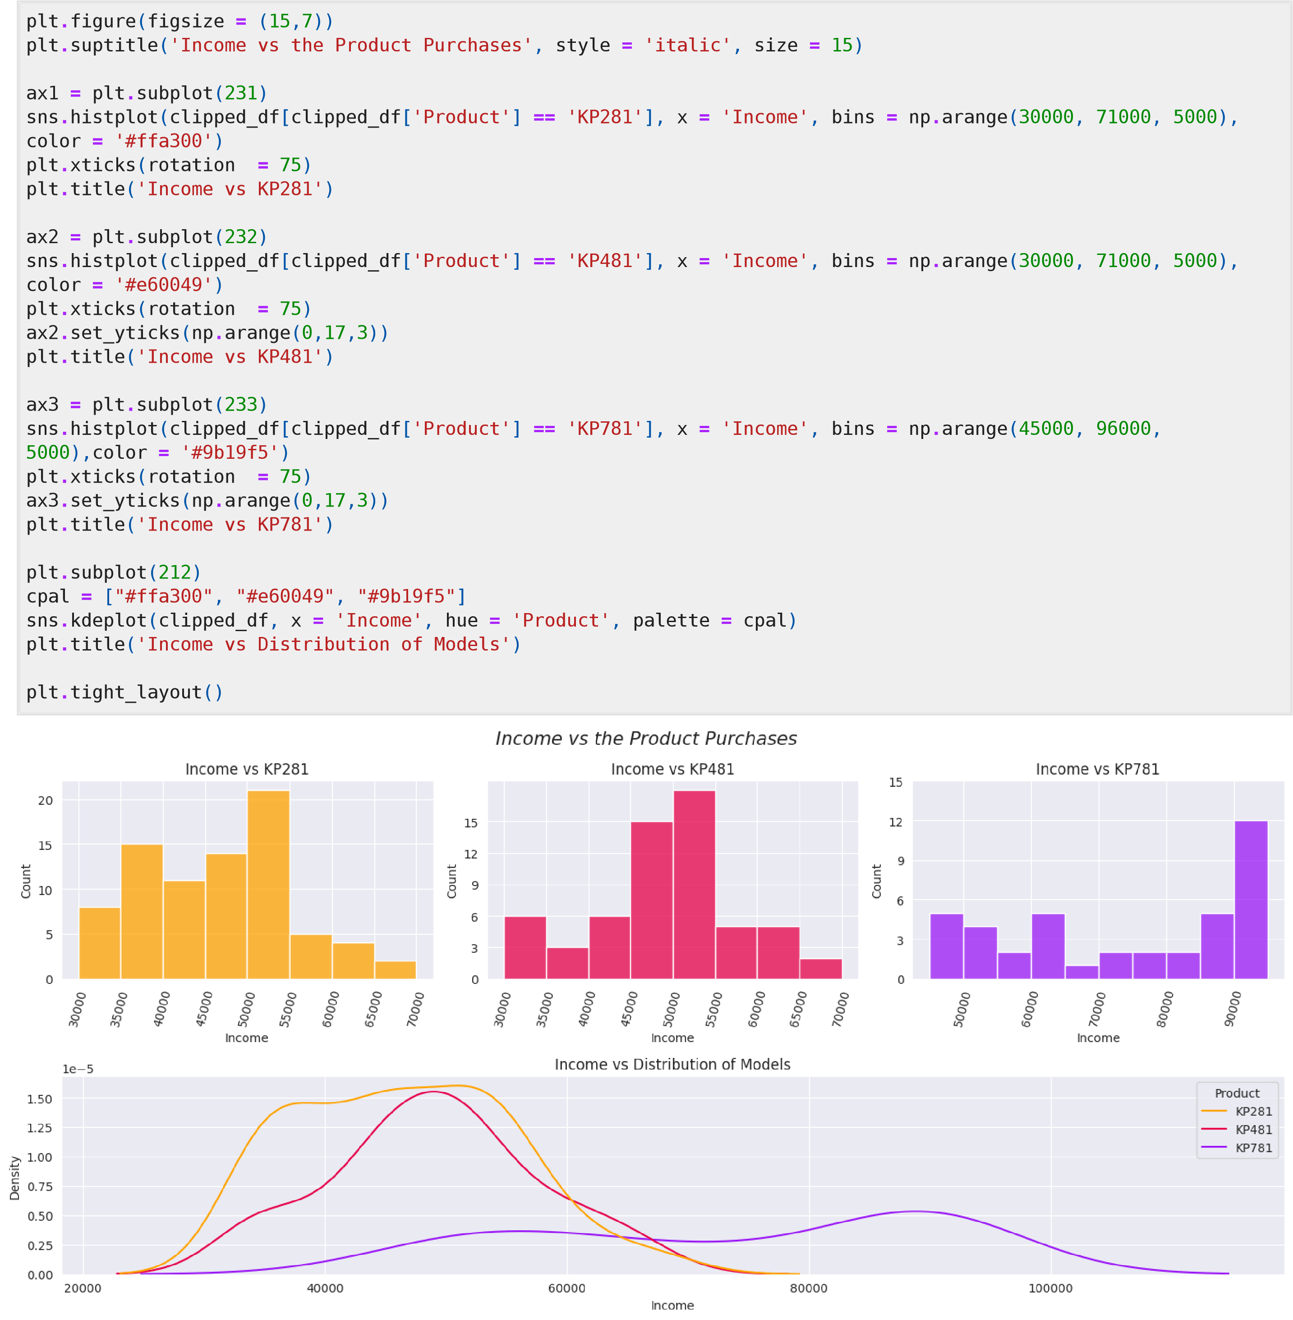

*Observations :*

KP281 is the most delivered product by the company. People having low to moderate income favor the KP281.

KP481 is most likely purchased by people with moderate income like from 45000-55000.

People earning over 80000 mostly buy the KP781 model of the treadmills.

## Relationships between the Continous variables and the output variable

### Expected Usage vs Miles to run of the customer

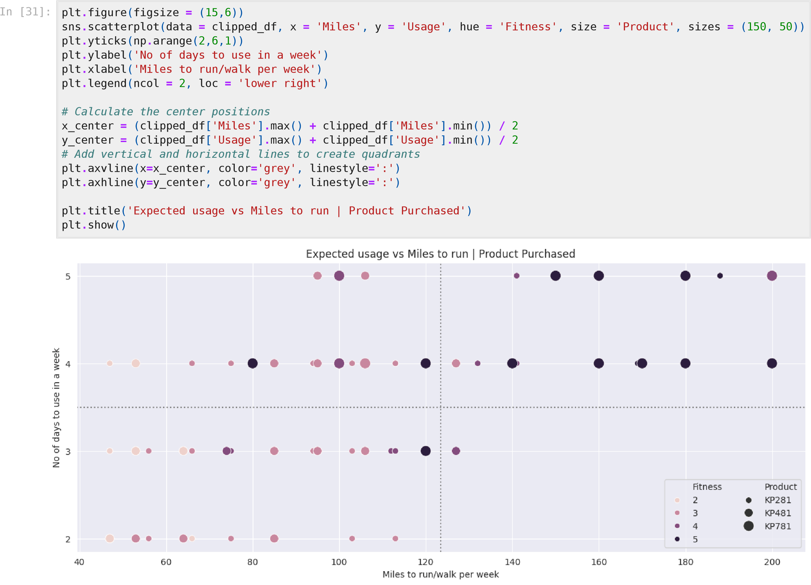

*Observations:*

Moderately t customers usually think of running less than 120. People running for more than 120 are usually on the tter end of the scale.

Generally, people who plan to use the treadmill for more than 3 days a week and plan to run at least 120 miles a week, seem to rate themselves on the tter end of the scale.

People who rate themselves the Fittest tend to run nothing less than 120 miles.

Another interesting thing to note from the upper half of the diagram is that people using the treadmills for more than 3 days, most likely buy the KP781.

clipped_df

[

clipped_df

[

'Usage'

]

**>**

3

][

'Product'

]

**.**

value_counts

()

In [32]:

Product

KP781 39

KP281 24

KP481 15

Name: count, dtype: int64

Out[32]:

Thus we can con rm the last observation to be true from the above output.

### Education vs the Product Purchased

*# Relationship between Education and Product purchased*

plt

**.**

figure

(

figsize

**=**

(

15

,

7

))

sns

**.**

countplot

(

data

**=**

clipped_df

,

x

**=**

'Education'

,

hue

**=**

'Product'

,

palette

**=**

'flare'

)

plt

**.**

ylabel

(

'Count'

)

plt

**.**

title

(

'Education of the Customer | Product Purcahsed'

)

plt

**.**

show

()

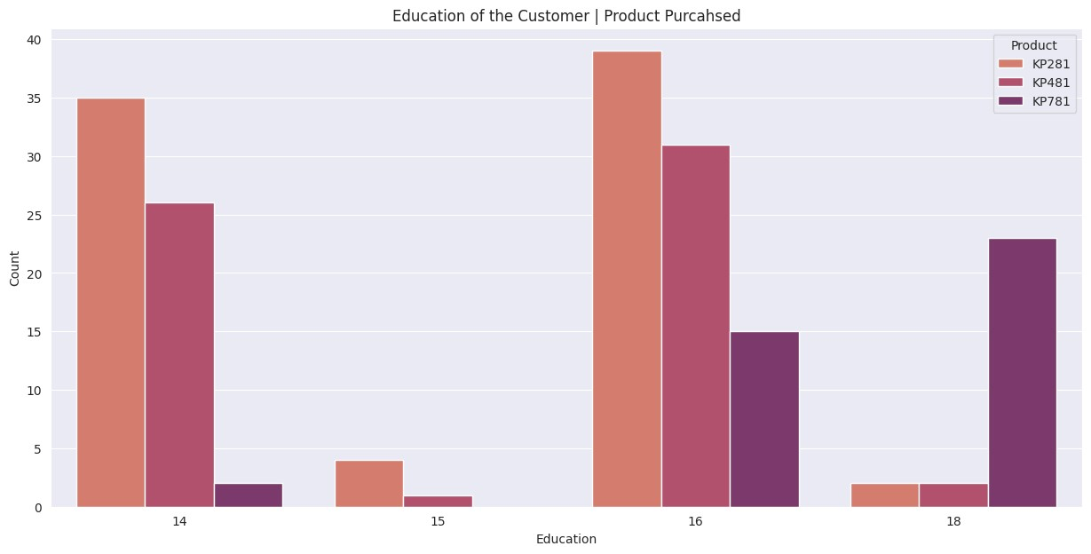

In [33]:

*Observations :*

More or less educated, the KP281 is the Customer's choice.

Very highly quali ed people are likely to go for the KP781, which can be correlated with their want to use the Advanced features o erred by the KP781.

### Age vs Income of the customer | Product Purchased

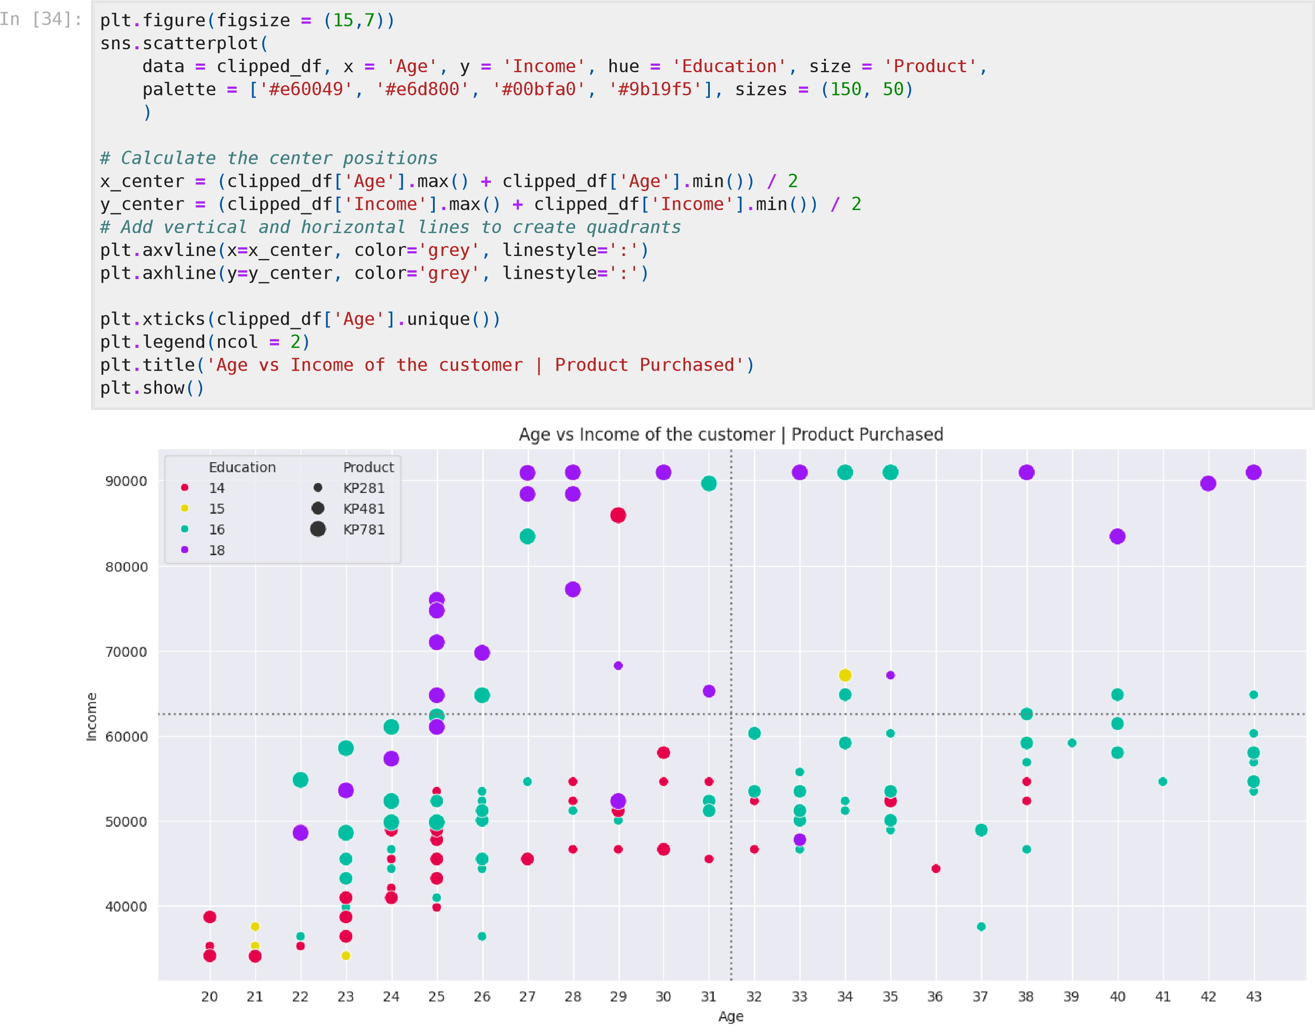

*Observations:*

People with higher number of educational years are likely to make a higher salary.

Since most tiny circles are either red or green, we can infer that people with lesser education tend to avoid the KP781 model.

The KP781 model is popular only among the 20-30 age group, very few beyond this group prefer the model, indicating most old people are no fans of advanced features in their treadmills.

# Correlation among di erent factors

corr_matrix

**=**

clipped_df

[

num_cols

]

**.**

corr

()

*# Plotting the correlation matrix*

plt

**.**

figure

(

figsize

**=**

(

10

,

8

))

sns

**.**

heatmap

(

corr_matrix

,

annot

**=**

**True**

,

cmap

**=**

'rocket_r'

,

vmin

**=**

**-**

1

,

vmax

**=**

1

)

plt

**.**

title

(

'Correlation Matrix of Continuous Variables'

)

plt

**.**

show

()

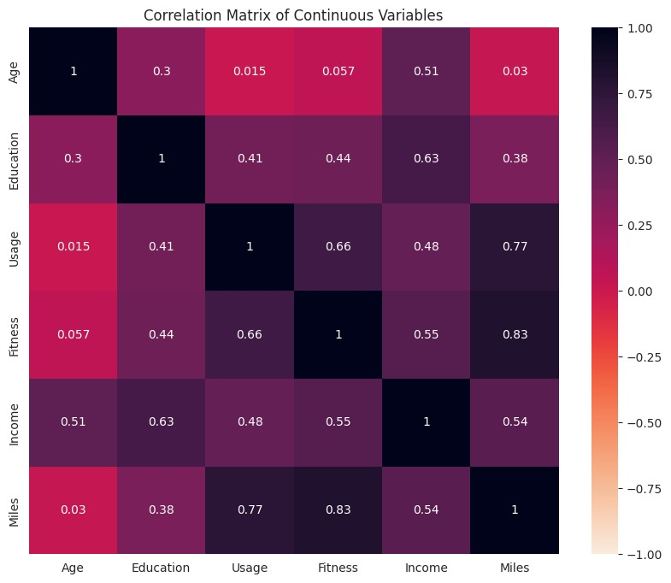

In [36]:

*Observations:*

All the columns are positively correlated with each other.

Age is highly correlated with Income and Education, which seems to be okay since a person earns and learns more with age.

Usage is highly correlated with Fitness & Miles. Exercise and tness do walk hand in hand.

Fitness & Income are also highly correlated, which tells us that Fitter people are likely to earn more.

*# Extracting few columns from original dataframe and using pairplot on this newly created data frame*

df_pairplot

**=**

clipped_df

[[

'Miles'

,

'Income'

,

'Fitness'

,

'Usage'

,

'Age'

,

'Product'

]]

sns

**.**

pairplot

(

data

**=**

df_pairplot

,

hue

**=**

'Product'

,

palette

**=**

'magma_r'

)

plt

**.**

show

()

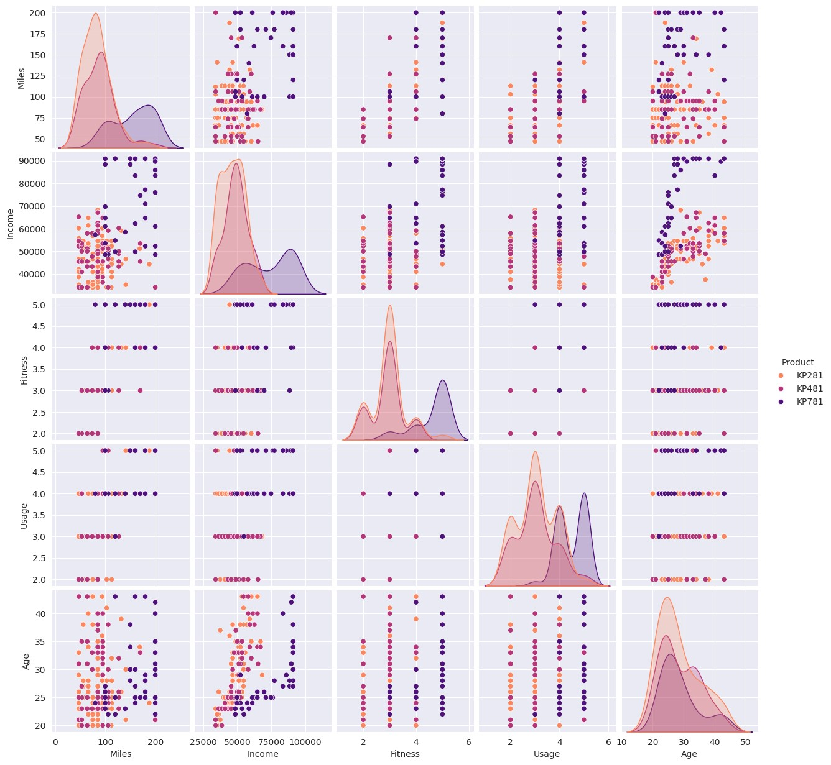

In [37]:

There are many insights we can get from this plot, like

Customers who are more t and have more number of miles run, they purchased product with high rating i.e. KP781, followed by KP481 and KP281

Customers with high level of tness and having higher incomes, purchased KP781 product followed by KP481 and KP281

Customers who purchased product KP781, have higher incomes and they run more number of miles comparing to other type of customers.

# Probability Representation

## Percentage of purchases

In [39]: (purchases_gender **:=** pd**.**crosstab(clipped_df['Product'], clipped_df['Gender'], margins **=** **True**, margins_name **=**

'Marginal Probability', normalize **=** **True**))

Out[39]: Gender Female Male Marginal Probability

Product

KP281 0.22 0.22 0.44

|  |  |  |  |  |  |  |  |
| --- | --- | --- | --- | --- | --- | --- | --- |
| KP481 |  | 0.16 | 0.17 |  |  |  | 0.33 |
| KP781 |  | 0.04 | 0.18 |  |  |  | 0.22 |
| Marginal Probability |  | 0.42 | 0.58 |  |  |  | 1.00 |

*

O

b

serv

a

tions

:

*

T

hus

,

we

h

a

ve

the

m

a

rgin

a

l

pro

bab

ilities

for

the

s

a

le

of

e

ac

h

produ

c

ts

a

nd

we

see

th

a

t

it

is

highest

for

the

KP

281

model

.

*# Marital Status*

(

purchases_marital_status

**:=**

pd

**.**

crosstab

(

clipped_df

[

'Product'

,

]

clipped_df

[

'MaritalStatus'

]

,

margins

**=**

**True**

,

margins_name

**=**

'Marginal Probability'

,

normalize

**=**

**True**

))

In [40]:

|  |  |  |  |  |  |  |
| --- | --- | --- | --- | --- | --- | --- |
| KP481 | 0.08 | 0.17 | 0.07 | 0.02 |  | 0.33 |
| KP781 | 0.00 | 0.01 | 0.10 | 0.12 |  | 0.22 |
| Marginal Probability | 0.18 | 0.38 | 0.29 | 0.14 |  | 1.00 |

Out[40]: MaritalStatus Partnered Single Marginal Probability

Product

*# Fitness*

(

purchases_fitness

**:=**

pd

**.**

crosstab

(

clipped_df

[

'Product'

]

,

clipped_df

[

'Fitness'

]

,

margins

**=**

**True**

,

margins_name

**=**

'Marginal Probability'

,

normalize

**=**

**True**

))

In [43]:

|  |  |  |  |  |  |
| --- | --- | --- | --- | --- | --- |
| KP281 | | 0.27 | 0.18 | | 0.44 |
| KP481 | |  | 0.20 | 0.13 |  | 0.33 | |
| KP781 | |  | 0.13 | 0.09 |  | 0.22 | |
| Marginal Probability | |  | 0.59 | 0.41 |  | 1.00 | |

In [41]:

*# Age*

(

purchases_age

**:=**

pd

**.**

crosstab

(

clipped_df

[

'Product'

]

,

clipped_df

[

'Age'

]

,

margins

**=**

**True**

,

margins_name

**=**

'Marginal

Probability'

,

normalize

**=**

**True**

))

Out[41]: Age 20 21 22 23 24 25 26 27 28 29 ... 35 36 37 38 39 40 41 42 43 Marginal

Probability

Product

KP281 0.03 0.02 0.02 0.04 0.03 0.04 0.04 0.02 0.03 0.02 ... 0.02 0.01 0.01 0.02 0.01 0.01 0.01 0.00 0.03 0.44

|  |  |  |  |  |  |  |  |  |  |  |  |  |  |  |  |  |  |  |  |  |  |  |
| --- | --- | --- | --- | --- | --- | --- | --- | --- | --- | --- | --- | --- | --- | --- | --- | --- | --- | --- | --- | --- | --- | --- |
| KP481 | 0.02 | 0.02 | 0.00 | 0.04 | 0.02 | 0.06 | 0.02 | 0.01 | 0.00 | 0.01 | ... | 0.02 | 0.00 | 0.01 | 0.01 | 0.00 | 0.02 | 0.00 | 0.00 | 0.01 |  | 0.33 |
| KP781 | 0.00 | 0.00 | 0.02 | 0.02 | 0.02 | 0.04 | 0.01 | 0.02 | 0.02 | 0.01 | ... | 0.01 | 0.00 | 0.00 | 0.01 | 0.00 | 0.01 | 0.00 | 0.01 | 0.02 |  | 0.22 |
| Marginal Probability | 0.06 | 0.04 | 0.04 | 0.10 | 0.07 | 0.14 | 0.07 | 0.04 | 0.05 | 0.03 | ... | 0.04 | 0.01 | 0.01 | 0.04 | 0.01 | 0.03 | 0.01 | 0.01 | 0.06 |  | 1.00 |

4 rows × 25 columns

*# Usage*

(

purchases_usage

**:=**

pd

**.**

crosstab

(

clipped_df

[

'Product'

,

]

clipped_df

[

'Usage'

]

,

margins

**=**

**True**

,

margins_name

**=**

'Marginal Probability'

,

normalize

**=**

**True**

))

U

s

a

ge

2

3

4

5

Ma

rgin

a

l

P

ro

bab

ility

In [42]:

Out[42]:

Product

KP281 0.11 0.21 0.12 0.01 0.44

Out[43]: Fitness 2 3 4 5 Marginal Probability

Product

KP281 0.08 0.30 0.05 0.01 0.44

|  |  |  |  |  |  |  |
| --- | --- | --- | --- | --- | --- | --- |
| KP481 | 0.07 | 0.22 | 0.04 | 0.00 |  | 0.33 |
| KP781 | 0.00 | 0.02 | 0.04 | 0.16 |  | 0.22 |
| Marginal Probability | 0.16 | 0.54 | 0.13 | 0.17 |  | 1.00 |

*# Education*

(

purchases_education

**:=**

pd

**.**

crosstab

(

clipped_df

[

'Product'

]

,

clipped_df

[

'Education'

]

,

margins

**=**

**True**

,

margins_name

**=**

'Marginal Probability'

,

normalize

**=**

**True**

))

E

du

ca

tion

14

15

16

18

Ma

rgin

a

l

P

ro

bab

ility

In [44]:

Out[44]:

Product

KP281 0.19 0.02 0.22 0.01 0.44

|  |  |  |  |  |  |  |  |
| --- | --- | --- | --- | --- | --- | --- | --- |
| KP481 | 0.14 | 0.01 | 0.17 | 0.01 |  |  | 0.33 |
| KP781 | 0.01 | 0.00 | 0.08 | 0.13 |  |  | 0.22 |
| Marginal Probability | 0.35 | 0.03 | 0.47 | 0.15 |  |  | 1.00 |

From the above crosstab results, we can de nitely gure out the probabilities of a customer purchasing a certain product based on their characteristics (or column).

For e.g., It can be identi ed,

*from the 'purchases_gender' dataframe, that the probability of a 'Male' person purchasing the KP281 is 0.22. from the 'purchases_ tness' dataframe, that the probability of a 'Fitness 5' rated person purcahsing the KP781 model is 0.16. from the 'purchases_maritalstatus', that the probability of a 'Partnered' person purchasing the KP481 model is 0.20.*

# Conditional Probabilities

Conditional probability is known as the possibility of an event or outcome happening, based on the existence of a previous event or outcome. It is calculated by multiplying the probability of the preceding event by the renewed probability of the succeeding, or conditional, event.

Formula : P(A|B) = N(A∩B)/N(B)

*What is the probability of selling a KP781 given that the customer is a Male?*

(

conProb_male781

**:=**

round

(

purchases_gender

**.**

loc

[

'KP781'

,

'Male'

]

**/**

purchases_gender

**.**

loc

[

'KP781'

,

'Marginal

Probability'

]

,

3

))

In [46]:

Out[46]: 0.825

*What is the probability of selling a KP781 given that the customer is a Female?*

(

conProb_male781

**:=**

round

(

purchases_gender

**.**

loc

[

'KP781'

,

'Female'

]

**/**

purchases_gender

**.**

loc

[

'KP781'

,

'Marginal

Probability'

]

,

3

))

In [47]:

Out[47]: 0.175

*Similarly, we can create an entire dataframe comprising of the conditional probabilities that the customer buys a particular model given that the gender of the customer is known.*

In [48]: *# Conditional Probabilities : by Gender*

(purchases_gender_cp **:=** purchases_gender[['Male', 'Female']]**.**loc['KP281':'KP781']**.**div(purchases_gender['Marginal

Probability']**.**loc['KP281':'KP781'], axis **=** 0))

|  |  |  |  |
| --- | --- | --- | --- |
| Out[48]: | Gender | Male | Female |

Product

|  |  |  |
| --- | --- | --- |
| KP281 | 0.50 | 0.50 |
| KP481 | 0.52 | 0.48 |
| KP781 | 0.82 | 0.18 |

In [49]: *# Conditional Probabilities : by Marital Status*

(purchases_marital_status_cp **:=** purchases_marital_status[['Partnered',

'Single']]**.**loc['KP281':'KP781']**.**div(purchases_marital_status['Marginal Probability']**.**loc['KP281':'KP781'], axis **=** 0))

|  |  |  |  |
| --- | --- | --- | --- |
| Out[49]: | MaritalStatus | Partnered | Single |

Product

|  |  |  |
| --- | --- | --- |
| KP281 | 0.60 | 0.40 |
| KP481 | 0.60 | 0.40 |
| KP781 | 0.57 | 0.42 |

# Customer Pro ling

Treadmills : KP281, KP481 & KP781

## KP281: Entry-Level Treadmill - $1,500

The KP281 is predominantly purchased by individuals aged between 20 and 30 years, who have completed approximately 14 to 16 years of education. This product appeals equally to both genders, with a signi cant proportion being partnered individuals. These customers typically have an annual income ranging from 35,000*to*55,000. They are low to moderately t and generally plan to run up to 120 miles per week, making the KP281 an excellent choice *for those starting their tness journey.* Ideal Customer:

*This model is perfect for young adults, both men and women, who are in the early stages of their careers, moderately t, and looking for an a ordable treadmill to support their tness goals within a budget.*

## KP481: Mid-Level Treadmill - $1,750

The KP481 is favored by partnered individuals aged between 20 and 35 years, with a notable preference among those in the 30-35 age group. These customers usually earn between 45,000*and*55,000 annually. The product appeals equally to both genders and is popular among those who have completed 14 to 16 years of education. Moderately t runners who plan to run around 120 miles per week nd the KP481 to be an ideal choice, providing the *perfect balance of features and performance.* Ideal Customer:

*This model suits partnered individuals in their late twenties to mid-thirties, moderately t, and looking for a reliable treadmill to support their regular running routines. It is especially attractive to those with a slightly higher budget seeking a balance between a ordability and advanced features.*

## KP781: Advanced Treadmill - $2,500

The KP781 is the preferred choice for highly educated, partnered males aged between 25 and 30 years, with an annual income exceeding $85,000. These customers typically rank high on the tness scale and plan to run approximately upto 200 miles per week. The advanced features of the KP781 cater to the needs of serious runners and tness enthusiasts with athletic tness, making it the top choice *for those seeking high performance and advanced functionality.* Ideal Customer:

*This model is ideal for high-income, highly educated young men who are serious about their tness and running routines. It is perfect for those seeking an advanced treadmill with superior features to support an intensive training schedule.*

# Recommendations

Focus marketing e orts on individuals aged 20 to 30, as they represent the largest customer base.

Highlight the KP481 model speci cally to customers in their early 30s. Consider targeted promotions and advertisements that promote KP481 for this age group.

Since males prefer the more advanced KP781 model, create marketing campaigns that emphasize the advanced features and higher performance of the KP781.

Since customers with partners or spouses tend to purchase more, develop marketing campaigns that target couples and families. Oer discounts or incentives for joint purchases or family bundles.

Emphasize the aordability and value of the KP281, especially for customers with low to moderate income. Highlight its features that provide good value for money.

Continue to innovate and add advanced features to the KP781 to maintain its appeal to high-income, highly educated customers, and those who prioritize tness. Collect feedback from this segment to understand their needs and preferences.

Based on customer feedback, consider incremental enhancements to the KP481 and KP281 models that could make them more attractive without signi cantly increasing costs.

Collaborate with tness in uencers and trainers(possibly female to attract the Female customers towards tness) who can endorse the treadmills and provide authentic reviews and usage tips.